|  |  |
| --- | --- |
| **Caractere** | **Binário** |
| 0 | 0011 0000 |
| 1 | 0011 0001 |
| 2 | 0011 0010 |
| 3 | 0011 0011 |
| 4 | 0011 0100 |
| 5 | 0011 0101 |
| 6 | 0011 0110 |
| 7 | 0011 0111 |
| 8 | 0011 1000 |
| 9 | 0011 1001 |

|  |  |
| --- | --- |
| **Caractere** | **Binário** |
| A | 0100 0001 |
| B | 0100 0010 |
| C | 0100 0011 |
| D | 0100 0100 |
| E | 0100 0101 |
| F | 0100 0110 |
| G | 0100 0111 |
| H | 0100 1000 |
| I | 0100 1001 |
| J | 0100 1010 |

|  |  |
| --- | --- |
| **Caractere** | **Binário** |
| a | 0110 0001 |
| b | 0110 0010 |
| c | 0110 0011 |
| d | 0011 0100 |
| e | 0011 0101 |
| f | 0011 0110 |
| g | 0011 0111 |
| h | 0011 1000 |
| i | 0011 1001 |
| j | 0011 1010 |

|  |  |  |  |  |  |  |  |  |  |  |  |
| --- | --- | --- | --- | --- | --- | --- | --- | --- | --- | --- | --- |
| T | e | s | t | a | n | d | o |  | 1 | 2 | 3 |
| 01010100 | 01100101 | 01110011 | 01110100 | 01100001 | 01101110 | 01100100 | 01101111 | 00100000 | 00110001 | 00110010 | 00110011 |

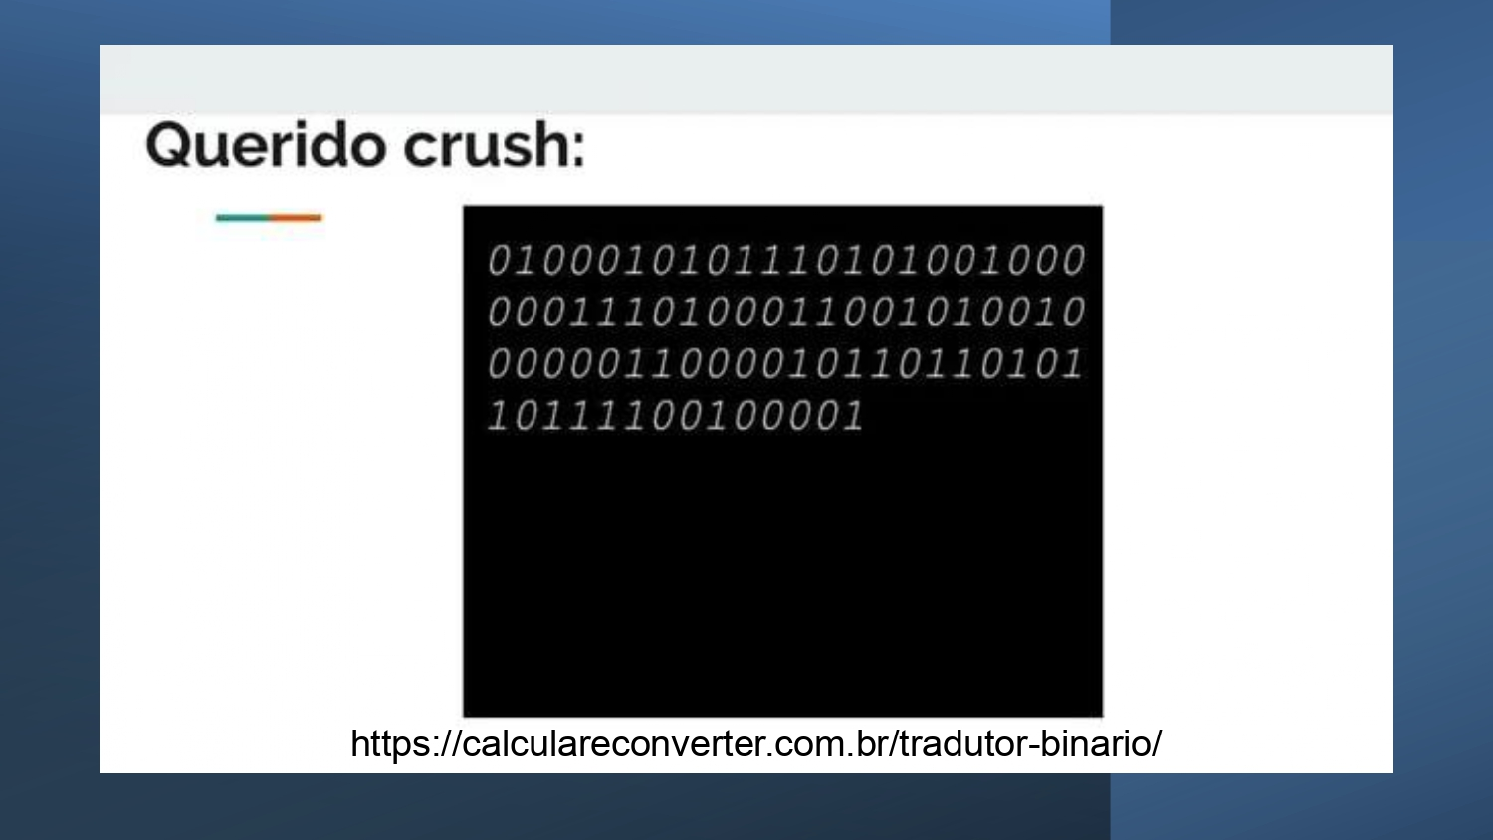

01000101 01110101 00100000 01110100 01100101 00100000 01100001 01101101 01101111 00100001

E U - T E - A M O !

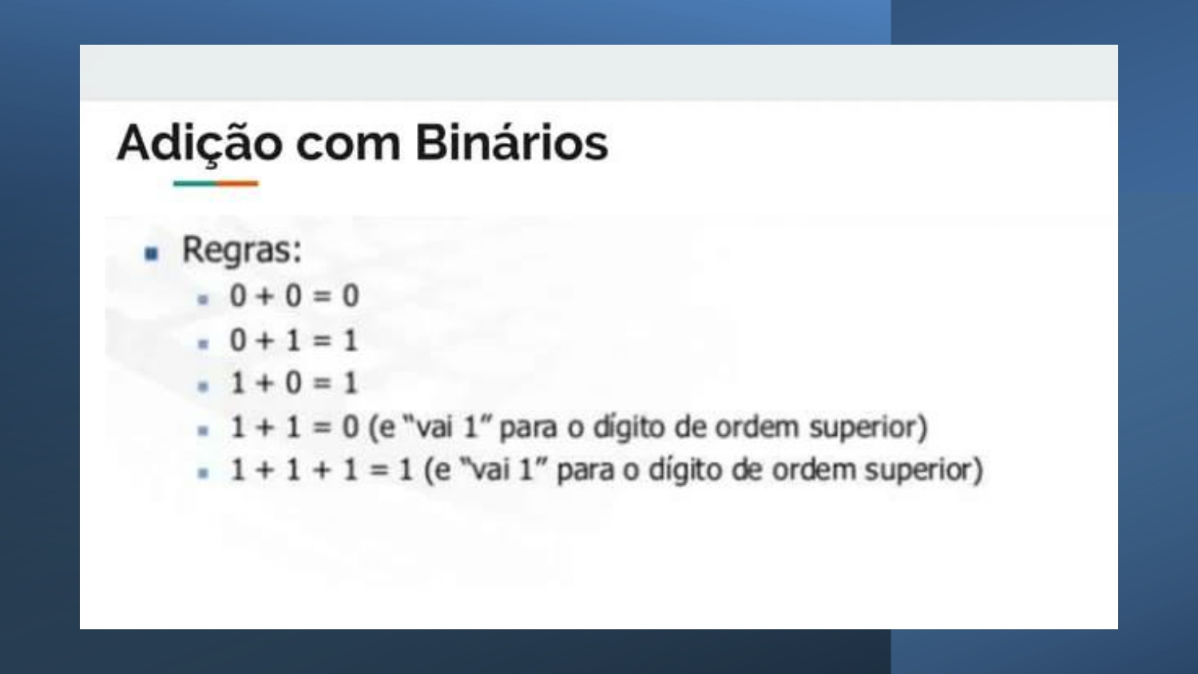

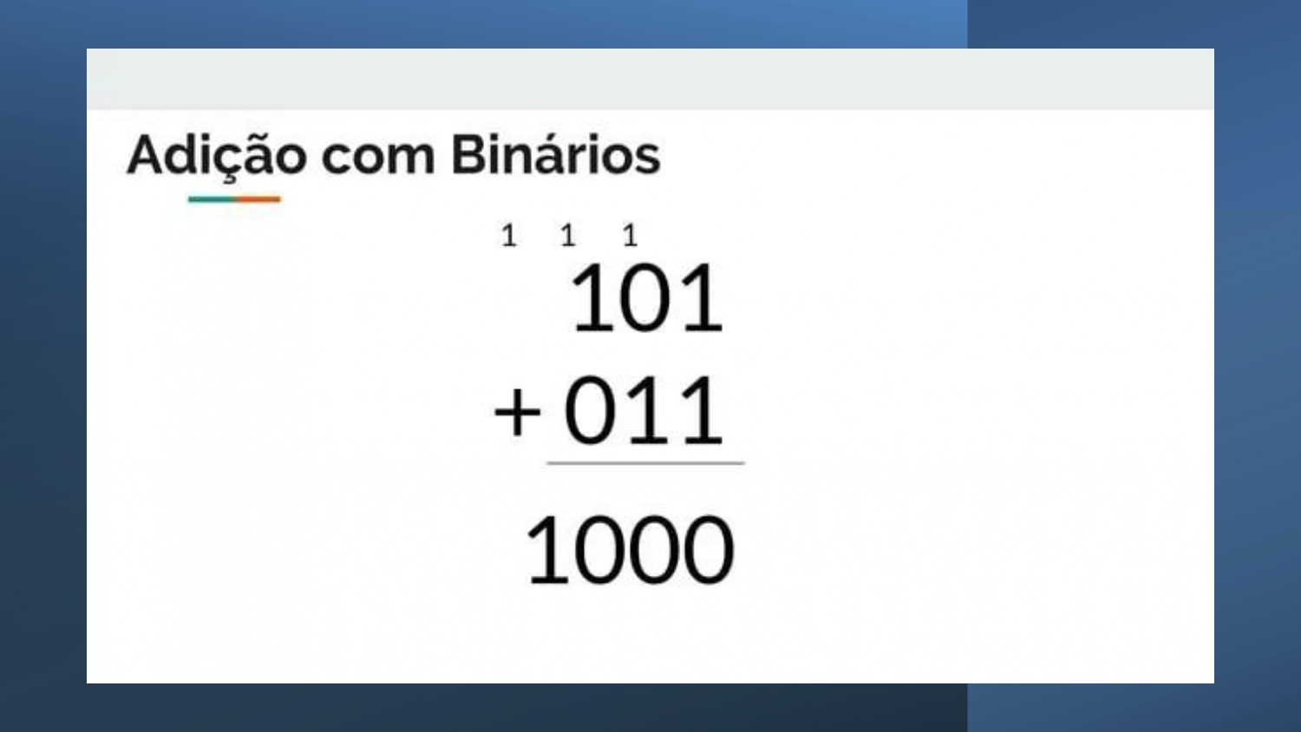

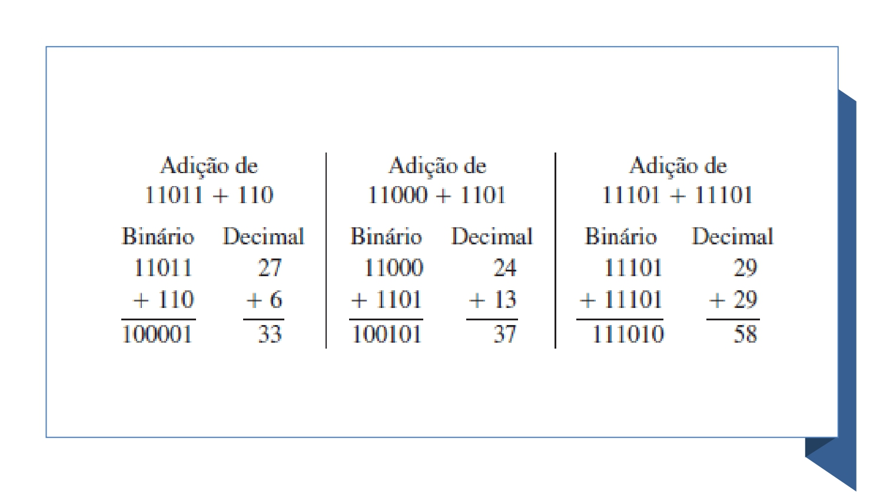

**Realize os cálculos abaixo:**

1. **= 10010110101**

100101101011

010

10010110101

1. **1100 + 1111 = 11011**

11100

1111

11011

1. **100000 + 100011 = 110011**

10000

100011

110011

1. **1100010 + 1000 = 1101010**

1100010

1000

1101010

1. **110001001 + 100011101 = 1010010110**

1100010101

100011101

1010010110